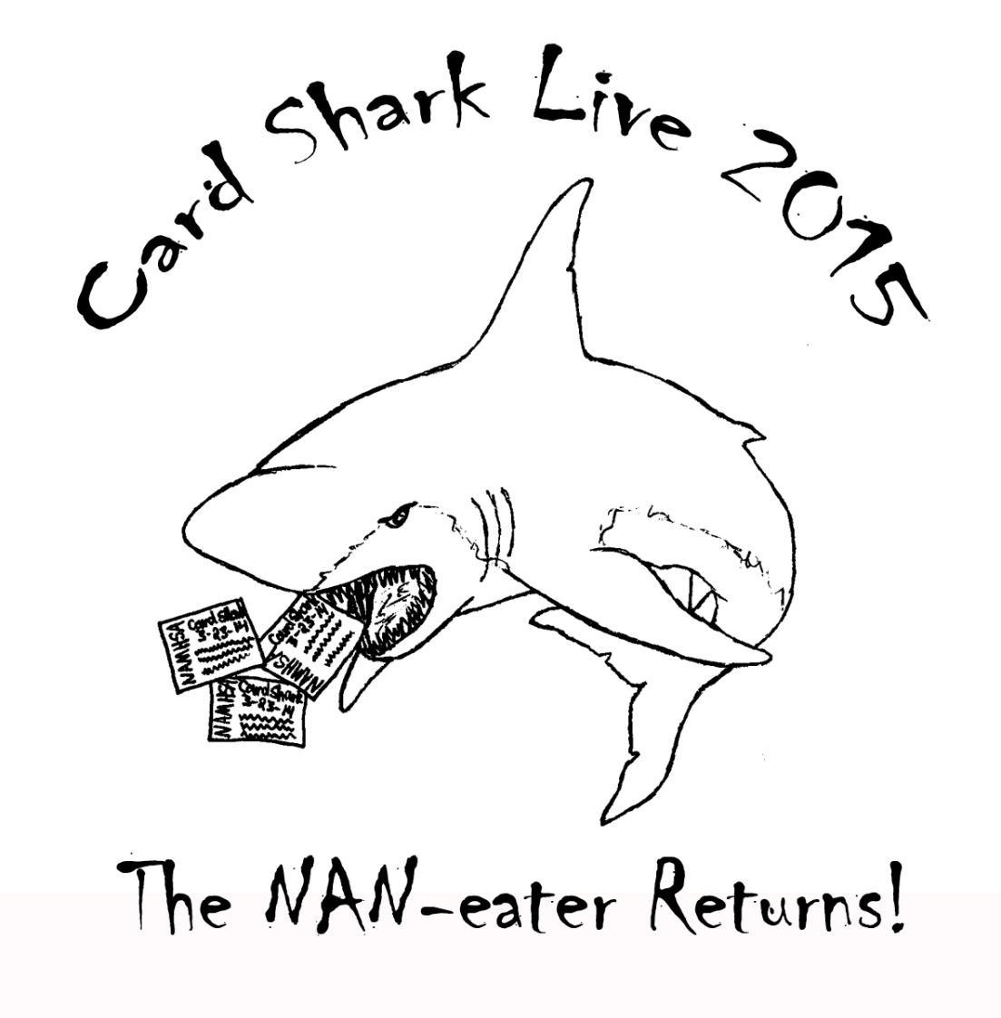

March 15, 2015
Rogers Adventist School
200 SW Academy Way
College Place, Washington 99324

Show Host: Bethany Shaw
Rebelsbutterfly@hotmail.com
http://cardsharklive2015.weebly.com
https://www.facebook.com/events/351086361737853/

Card Shark Live 2015 Class List

Ten divisions with multiple classes

*Classes may be split/combined at judge’s discretion*

RIGHT AFTER LUNCH:

OF Fantasy (Pegusi, unicorn, pegicorn, thestral ONLY)

CM Fantasy (Pegusi, unicorn, pegicorn, thestral ONLY)

OF Breyer/Other Plastic

Traditional/Classic Scales
Judge:
Foals

1. Sport breed Foals

2. Gaited foals

3. Other light foals

4. Solid Stock Breed Foals

5. Color Stock breed foals

6. Draft foals

7. Pony foals

8. Other pure/part foals

Foal Championship

Sport Breeds
9. TB/STB
10. European WB
11. All other Purebred WB/Sport-horse

12. Carriage (Friesians, etc)

13. Other pure/part sport
Sport Breed Championship
Light breeds
14. Weather Girl Arabian

15. Arabian other than Weather Girl
16. Part-Arab/NSH
17. ASB/TWH/MFT
18.0All Spanish
19. Morgan
20. Other pure/part light
Light breed Championship

Draft breeds
21. Clydesdale/Shire
22. Belgian/Percheron/similar

23. Spotted Drafts
24. Other pure part/mix
Draft Championship
Pony Breeds
25. Heavy/Stock type (British) pony
26. Light/Sport type (Am. Shetland) Pony
27. Other pure/part Pony
Pony Championship
Stock breeds
28. Quarter Horse
29. Appaloosa
30. Paint
31. Mustang
32. Other pure/part stock
Stock Championship

Other Equine
33. Mule
34. Donkey
35. Zebra/Exotic/Other
Exotic Championship
OF Collectability*
36. Breyer OOAK or Test Run
37. Connoisseur
38. Breyer special run of 2-500
39. Breyer special run of 501-1500

40. Breyer Special run of 1501-3000

41. Breyer Special run of 3001+
42. Vintage Regular Run (1979 and older)

43. Modern Regular Run (1980 and newer)
44. All decorator (ex: charcoal, woodgrain, gold charm etc)
45. All unrealistic (pinks, patterns, holiday & Halloween etc)
46. Other plastics collectability (Schleich, etc)

Collectability Championship
OF Breyer/Other Plastic Division Championship

OF STONE

Traditional Scales
Judge:

Foals

1. QH

2. Appaloosa

3. Paint

4. Arabian

5. Part Arabian

6. Other Pure/Part

Foal Championship
Sport Breeds
7. TB/STB
8. German WB
9. All other WB/Sport-horses
10. Other pure/part sport

Sport Breed Championship
Light breeds
11. Arabian
12. Part-Arab/NSH
13. All Gaited
14. All Spanish
15. Morgan
16. Other pure/part light
Light breed Championship
Stock breeds
17. Quarter Horse
18. Appaloosa
19. Paint
20. Mustang
21. Other pure/part stock
Stock Championship
Draft/Pony/Other Equine breeds
22. Clydesdale/Shire
23. Belgian/Percheron/similar
24. All Spotted Drafts
25. Other pure part Draft
26. Heavy/Stock type (British) pony
27. Light/Sport type (Welsh, Am. Shetland) Pony
28. Other pure/part Pony
Draft/Pony/Other Equine Championship
Stone Collectability*
29. All unrealistic/decorator
30. YCI/Artisan Hall/OOAK
31. Run of up to 30
32. Run of 31-100
33. Run of 100+

34. DAH
35. Regular Run

Collectability Championship
OF Traditional Stone Division Championship

OF Breyer/Stone/Other Plastic MINI

Bit/Pebbles, Stablemate/Chips & Micro Mini Scale
Judge:

Foals

1. Light/Sport/Gaited Foal

2. Stock foals

3. Draft/pony foals

4. Other pure/part foals

Foal Championship
Sport Breeds
5. TB/STB
6. European WB

7. All other WB/Sport-horse
8. Carriage (Friesians, etc)
9. Other pure/part sport
Sport Breed Championship
Light breeds
10. Arabian - Breyer/Other
11. Arabian - Stone
12. Part-Arabian - Breyer/Other
13. Part-Arabian - Stone
14. NSH/ASB/TWH
15. All Spanish Breeds
16. Morgan
17. Other pure/part light
Light breed Championship
Draft breeds
18. Clydesdale/Shire - Breyer/Other
19. Clydesdale/Shire - Stone
20. Belgian/Percheron/similar
21. Other pure part/mix
Draft Championship
Pony Breeds
22. Heavy/Stock type (British) pony
23. Light/Sport type (Welsh, Am. Shetland) Pony
24. Other pure/part Pony
Pony Championship
Stock breeds
25. Quarter Horse
26. Appaloosa
27. Paint
28. Mustang
29. Other pure/part stock
Stock Championship
Long-ears/Other Equine
30. Donkey
31. Mule
32. Other Equine
Longears/Other Championship

OF Mini Collectability

Stone
33. OOAK/YCI/Artisan Hall
34. Run of 50 or less
35. Run of 50+
36. DAH
Breyer

37. Connoisseur
38. SR Realistic G1-G2

39. SR Realistic G3-G4
40. Regular Run G1-G2

41. Regular Run G3-G4
42. All decorators & unrealistic colors

Other
43. Other plastics collectability (Schleich, Hartland, etc)
Collectability Championship
OF Breyer/Other Mini Plastic Division Championship

Trad/Mini Artist Resin

(Same class list, separate divisions, tables together)
Judge:

Foals

1. Sport breed Foals

2. Light/Gaited foals

3. Stock breed foals

4. Draft/Pony foals

5. Exotic/Long-ear foals

6. Other pure/part foals

Foal Championship

Sport Breeds
7. TB/STB
8. All WB/Sporthorses
9. Carriage (Friesians, etc)
10. Other pure/part sport

Sport Breed Championship
Light breeds
11. Arabian
12. All Gaited Breeds
13. All Spanish Breeds
14. Morgan
15. Other pure/part light

Light breed Championship
Draft breeds
16. Clydesdale/Shire
17. Belgian/Percheron
18. Other pure part Draft
Draft Championship
Pony Breeds
19. Heavy/Stock type (British) pony
20. Light/Sport type (Welsh, Am. Shetland) Pony
21. Other pure/part Pony
Pony Championship
Stock breeds
22. Quarter Horse
23. Appaloosa
24. Paint
25. Mustang
26. Other pure/part stock
Stock Championship
Other Equine
27. Mule/Donkey
28. Zebra/Exotic
29. Other pure part exotic.
Exotic Championship
Workmanship

30. Portrait Horse (must have photo of reference horse)
31. Bay/Brown
32. Black
33. Chestnut
34. Dilutes
35. Appaloosa pattern
36. Tobiano pattern

37. Overo/All Other Pinto
38. Grey/roans
39. Unrealistic
40. Other (ex: zebra pattern)

Workmanship Championship
Artist Resin Division Championships

Trad/Mini Customized

(Same class list, separate divisions, tables together)
Judge:

Foals

1. Sport breed Foals

2. Light/Gaited foals

3. Stock breed foals

4. Draft/Pony foals

5. Other pure/part foals

Foal Championship

Sport Breeds
6. TB/STB
7. All Warmbloods/Sport-horses
8. Carriage (Friesians, etc)
9. Other pure/part sport
Sport Breed Championship
Light breeds
10. Arabian
11. Part-Arab/NSH
12. All Gaited Breeds
13. All Spanish Breeds
14. Morgan
15. Other pure/part light
Light breed Championship
Draft breeds
16. Clydesdale/Shire
17. Belgian/Percheron
18. Other pure part Draft
Draft Championship

Pony Breeds
19. Heavy/Stock type (British) pony
20. Light/Sport type (Welsh, Am. Shetland) Pony
21. Other pure/part Pony
Pony Championship
Stock breeds
22. Quarter Horse
23. Appaloosa
24. Paint
25. Mustang
26. Other pure/part stock

Stock Championship
Other Equine
27. Mule/Donkey
28. Zebra/Exotic
29. Other pure part exotic.
Exotic Championship
Workmanship

30. Portait Horse (must have photo of live horse)
31. Bay/Brown
32. Black
33. Chestnut
34. Dilutes
35. Appaloosa pattern
36. Tobiano pattern

37. Overo/Other pinto pattern
38. Grey/White

39. Roan
40. Other realistic (ex: zebra pattern, donkey)
41. Unrealistic

Workmanship Championship
Custom Plastic Division Championships

OF China/Resin and CG China

All scales (Same class list, separate divisions, same table)

Judge:

Foals

1. Light/Gaited

2. Sport

3. Stock

4. Draft/Pony

5. Other Pure/Part

Foal Championship

Light/Sport

6. Arabian/Part Arabian

7. Morgan/Gaited

8. TB/STB

9. Carriage

10. All WB

11. Sport-horse

12. Other Pure/Part Sport

Light Sport Championship

Stock

13. QH

14. Appaloosa

15. Paint

16. Mustang

17. Donkey/Mule

18. Exotic/Other Equine

19. Other Pure/Part Other

Stock Championship

Draft/Pony

20. Clydesdale/shire

21. Belgian/Percheron

22. Other Pure/Part Draft

23. British Pony

24. American Pony

25. Other Pure/Part Pony

Draft/Pony Championship

OF China/Resin Collectibility

26. Hagen-Renaker Mini

27. Hagen-Renaker Non Mini

28. Breyer

29. Other American Manufacturers

30. European Manufacturers

31. Other Manufacturers

Collectibility Championship

CG China Workmanship

32. Bay

33. Chestnut

34. All Greys

35. Pinto

36. Appaloosa Pattern

37. Other Colors

CG China Workmanship Championship

OF China/Resin Division Championship /CG China Division Championship

Performance

All makes/scales (May be split at judge’s discretion)

Judge:

Other Performance

1. Harness

2. Arabian Costume

3. Native American Costume

4. Parade/Other Costume

5. Other Performance

Other Performance Championship

Western Performance

6. Judged Stock Work

7. Timed Stock Work

8. Reining

9. Western Trail- Stock Breed

10. Western Trail- Other breed

11. Western Games

12. Western Pleasure

13. Other Western Performance

Western Performance Championship

English Performance

14. Dressage

15. Hunter/Jumper/Cross Country

16. English Trail- Stock Breed

17. English Trail- Other Breed

18. Saddle Seat/Hunt Seat

19. English Games

20. English Pleasure

21. Other English Performance

English Performance Championship

Performance Division Championship

Card Shark Live 2015

Rules/Info:

Date: March 15, 2015

Hours:
Set up begins at 7 AM
Judging will begin at 8 AM

Lunch will be about noon

We hope to end about 5 PM
Location:
Rogers Adventist School (Multi-Purpose Room)

200 SW Academy Way, College Place, WA 99324

This is the same location as Sweet Onion 2014.
Eligibility: This show is open for anyone to enter. There is no membership required. As per NAMHSA rules, the show holder and anyone in their immediate family may not enter the show. A judge who customized or sculpted a model shall not judge that model in any class. Judges shall not compete in any divisions that they are judging.
Space: We will have space for 32 entrants. Each shower will be assigned a 6' table. Please plan accordingly. Don't wait to send in your entry! Additional tables are $40.
Divisions:
OF Breyer/Other Plastics -- any Breyer or other plastic model that is in original factory condition, in Traditional (1:9) or Classic (1:12) scale.
OF Stone -- any Stone model that is in original factory condition, in 1:9 or 1:12 scale.
OF Plastic Mini -- any Breyer, Stone, or other plastic model that is in original factory condition, in Little Bit/Pebbles (1:24), Stablemate/Chips (1:32), or Mini Whinny (1:64) scale.
Artist Resins Trad – Any AR in classic or traditional scale.

Artist Resin Mini – Any AR in Stablemates, Chips, Pebbles, Paddock Pal, or Mirco scale.
Custom Trad – any Traditional or Classic scale plastic make of model horse that has been customized in any way.

Custom Mini – Any SM/Chip/Pebbles/Paddock Pals/micro scale plastic make of model horse that has been customized in any way.
*Newly NAN-eligbile FANTASY equines will be judged first thing upon returning from the lunch hour! There will be one OF and one CM class.

Judging:
Please give the judges their space! Ask any questions before the class or the show. All of the judges' decisions are final. Classes may be split or combined upon judge’s discretion. No unsportsmanlike behavior will be tolerated.

Judging criteria :
Breed Classes - Conformation, Breed Standards, Condition/Workmanship
Collectability - Rarity, Age, Condition, Desirability/Value
Workmanship - Prepping/Sculpting Quality, Detail, Paint/Finish Work
Judges will be allowed to use breed books at their discretion to assist in placing horses in the correct breed class.
Judges are allowed to show models in divisions that they are not judging.
Halters are not required in halter classes, but an improper or ill-fitting halter may be detrimental to the entrants placing.
Foals may only enter in foal classes & may NOT cross enter in open breed classes.
Foals may enter collectability and workmanship classes.
Entry Limit: There is no entry limit per shower but there will be a 4 horse limit per halter classes. A 3 horse limit on performance classes. Please bring an ascending list of your models on the day of the show. Include model's tag number, name, breed, and finish. We will be using the Region 1 tag saver program. (See below for more info) If you wish to show more than the limit of horses, please plan to pay $1 for each additional horse per class. Simply place $1 next to each over-limit horse on the table.
Leg Tags: Each shower must provide their own legs tags & must provide a model list the day of the show. I would advise you check out the Region 1 tag saver program and get signed up with a number (it is free) Tag Program:
Each entrant that does not currently have a Region 1 tag saver number will be assigned a temporary shower number. Please let the show holder know if you are in need of a shower number. Leg Tags should include the shower number, specific model #, and model breed assignment. For example: shower code=S, model #=1, breed=Shire
S-1
Shire
Please print neatly so that judges may clearly read each tag.
Lunch: We will break around noon for lunch for 45-60 minutes regardless of where we are in the classes. Lunch will be provided for judges by TBA.
Awards: Classes will be placed 1st-6th. NAN cards will be awarded for 1st-2nd place equines. You are welcome to donate back any ribbons you do not wish to keep.
Results: results will be provided either via email or mailed. Entrants requesting mailed results will need to provide an SASE by show day.
NAMHSA Member show: All equines that place either 1st or 2nd in their class will be awarded a NAN card that will be good for NAN in 2015 -2018. Any equine that wins a NAN card may enter at NAN. For more information on this, please see their website at www.namhsa.org.
Classes: All classes will be called simultaneously on separate tables. Table markers will indicate what table models should be placed on. Showers are responsible for getting their models on the table in a timely manner. Horses left behind on the table after their class will be put in pony pound.

Portrait Horse Class: Newly added to Workmanship for the Custom model divisions, this class allows horses made to look like a real horse even footing. This class is an option in Workmanship for a chance to win a yellow NAN card. You may not cross enter Portrait Horse AND a color class. To show in the Portrait Horse class you are required to have a photo of the reference horse with your model as documentation or your model will not be judged.
Raffle: Any and all donations are welcome. Raffle tickets will be available for purchase on show day for $1 each, or 6 for $5. Drawing will begin after lunch. You do NOT need to be present to win.
Advertising: To advertise in the show program, please see the price list on the entry form. Contact rebelsbutterfly@hotmail.com to be listed. Ad must be copy ready. Show program will be printed in black & white so keep this in mind when submitting an ad for the program.

Entry deadline: March 8th, 2015
ENTRY INFORMATION:
- No fee/entry sharing is allowed. Everyone must personally own the models they are exhibiting, unless they are being proxy shown.
- Proxy entries must clearly mark their entry form as a Proxy Entry and the entry will not be allocated table space (this shall be the responsibility of the proxy shower unless other arrangements are made).
- The Refund Policy is as follows: All requests for refunds must be made in writing at least 7 days prior to the show. Refunds will ONLY be made for extenuating circumstances.
- Please note: There will be a $55 charge for any checks returned for insufficient funds (bank fee plus $10).
Selling: Selling is allowed at show tables.
Proxy Showing: Proxy Showers are welcome & must follow entry rules. Please state on your entry who will be proxy showing your models.
Animals: No animals are allowed unless they are service animals, such as seeing eye dogs.
Children: Model shows are not a place for unattended children. Each shower knows if their children are able to be at the show. Please be considerate of others and keep in mind the liability risks.

Card Shark Live 2015 Entry Form

Mail Entries to: Personal Check and PayPal accepted
Bethany Shaw
53184 Lewis Lane
Milton-Freewater, OR
97862

Name: __________________________________________________________________
Address: __________________________________________________________________
City, State, Zip:______________________________________________________
Email:_____________________________________________________________
Entry Deadline: Friday, March 7th

Unlimited Entry (7 or more models) |  | $55.00
Per Model Fee (Limit 6) |  | $5.00
Proxy Entry –proxy-shower will be: |  | $25.00
Sales Table or Extra Table |  | $40.00
Show Program Business Card Ad |  | $3.00
Show Program One Half Page Ad |  | $5.00
Show Program Full Page Ad |  | $10.00
NAMHSA member discount (must be current) |  | -$5
 |  |  | TOTAL
Region 1 Tag Number (if available):_____________________

I’d like my table near (I’ll do my best to accommodate):__________________________________

I will be participating in the following divisions (this just helps me to get an idea of where everyone will be showing):
______________________________________________________________________
______________________________________________________________________
______________________________________________________________________

DONATIONS for the Raffle (optional): I plan to donate the following item(s): do not have to have a description prior to show day, but it’s helpful to plan and ideal that I can put a photo on the website!
________________________________________________________________

Please submit an easy to read horse list by show day morning.
Entrants with horse lists submitted prior to show day will be entered into a special drawing at the show! Additions/ Changes may be made after submission up until the end of the show.

I hereby release Bethany Shaw, the event coordinators, judges, helpers for Card Shark Live, and all employees of Rogers Adventist Shchool, as well as the facility management, of any liability for any personal injury, property damage or loss that may occur during the course of this event. I further understand that all judges' decisions are final, and I agree not to hold any judge or member of the event staff liable for any decision or judgment that is made in the course of the event. I have read and understood the rules of Card Shark Live and agree to abide by these rules. I understand that if these rules are violated, I may be asked to leave the class or event at any time with no refund of fees.
Signature: __________________________________________ Date: ________________

Parent/Guardian: ____________________________________ Date: ________________

